19------------------
TABLE of CONTENTS
UPDATES

Date:__4/14/19_______________

Date:________________________

Date:________________________

Date:________________________

Date:________________________

Emergency Evacuation Plan
William Knox Holt Library

Contributors:
Latest revision by
Latest evacuation plan / maps revision by

NOTE
This does not address the Rite Aid Information Commons Library
All Cell phone numbers are for emergency contact only.

** NOTE: IS CURRENTLY BEING INSTALLED DURING RENOVATIONS. MAPS INDICATE WHERE THEY ARE OR WILL BE LOCATED.

Emergency Phone Numbers…………………………………………………………………………….…..…… RED pg. 3

Emergency Resources……………………………………………………………………………………………………pg. 4

Fire/Explosion Instructions…………………………………………………………………………….…….… BLUE pg. 5

Earthquake Instructions…………………………….………………………………………………....…… ORANGE pg. 6

Bomb Threats ………………………………………………………………………………………………… GREEN pg. 7

Civil Disturbance/Terrorist Attack (outside the building)…………………………………………….… YELLOW pg. 8

At Risk Visitors / Intruders…..…..………………………………………………….....………………….. PURPLE pg. 9

Emergency Evacuation Plan and Maps………………………………………………………………….……………pg. 10

Leads & Lead Responsibilities…………………………………………… ………….…….…….…..… Light blue pg. 18

Evacuation Instructions: Dos and Do-not’s…………………………………….……………..……………..…….…pg. 19

Area of Refuge / Emergency Phone Button.……………………………………………………………..…..………..pg. 21

Designated Safe Outside Meeting Area………………………………………………………….…………………….pg. 22

William Knox Holt Library Building Occupants………………………………. …..……………….………. PINK pg. 23

William Knox Holt Library Building Reporting Protocols ……………………………………..…………….……..pg. 24

Stop the Bleed…………………………………………………………………………………………………………..Appendix
Emergency Phone Numbers

3

Public Safety: Emergency: 000-000 - 0000
Non emergency: 000-000-0000
STRIPES: 000-000-0000

Business Manager: Office: 000-000-0000
Cell: 000-000-0000

Director CTL: Office: 000-000-0000
Cell: 000-000-0000

Head of Discovery Services: Ask Us Desk: 000-000-0000
Office: 000-000-0000
Cell: 000-000-0000

Head of Special Collections: Office: 000-000-0000
Cell: 000-000-0000

University Librarian: Office: 000-000-0000
Cell: 000-000-0000

Vice Provost Undergrad Education: Office: 000-000-0000
Cell: 000-000-0000

EMERGENCY RESOURCES

Emergency Area Source of Assistance Telephone Number
Emergency Services Police, Fire, Medical 000-000-0000 (NON-EM: 000-000-0000)
Electrical/Gas/Water/Sewer Physical Plant 000-000-0000
Elevator Services Physical Plant 000-000-0000
Flood Emergency State of California 800-952-5530 Hospitals/Clinics Health Center 000-000-0000
Kaiser Clinic ____________ _ 000-000-0000
Dameron Hospital 000-000-0000
St. Joseph’s Hospital 000-000-0000
Telephone Outage Telecommunications 000-000-0000
Weather Information National Weather Service 916-979-3051
Road Conditions California Highway Patrol 800-427-7623
Animal Control Physical Plant 000-000-0000 Cowell Wellness Center University 000-000-0000
FIRE / EXPLOSION

5

Signals | - Use the intercom or bullhorn to notify Persons.  - Use the phone at the Ask Us Desk to call Public Safety at 000-000-0000 & alert University Librarian’s office: 000-000-0000, cell: 000-000-0000.
Admin/Office Staff | - Call Public Safety at 000-000-0000.  - Follow reporting protocol pg. 24, (University Librarian ---------------: office: 000-000-0000, Cell: 000-000-0000).  - Pull fire alarm. (SEE maps below).  - Get and use fire extinguisher, if necessary.  - University Librarian will be main spokesman for staff/faculty.  - Emergency contact information is needed from everyone in the William Knox Holt Library. See pg. 23.
Custodial Staff | - Assist if available.
Staff | - Escort students outside to the area south of the building lawn area or the North of the building to the lawn area, (Knoles Lawn), whichever is safe.  - Check in following protocol pg. 24.  - Have phone numbers of University Librarian 000-000-0000, cell: 000-000-0000.  - Have phone numbers of Building Leads available. See pg.18.
Inside Building | - Assist disabled persons in areas of refuge downstairs. DO NOT use elevator.  - Escort students outside to Knoles Lawn or outside lawn south of William Knox Holt Library. See designated area map below.  - Evacuation Routes (See list of routes and maps).  - Close all doors after exiting offices to minimize fire danger.  - Make sure offices are vacated on all floors. Each designated team leader can check their own area and nearby offices.  - Keep entrances and stairways clear for emergency personnel.
Outside Building | - DO NOT re-enter the building.  - Set up a command post as soon as possible in designated meeting area, away from the building.  - University Librarian --------------------: office: 000-000-0000, Cell: 000-000-0000 (or designee) will be in charge.  - Make sure everyone is accounted for.
EARTHQUAKE

6

Signals | - Use the intercom or bullhorn to notify Persons.  - Use the phone at the Ask Us Desk to call Public Safety at 000-000-0000 & alert University Librarian’s office: 000-000-0000, cell: 000-000-0000.
Admin/Office Staff | - Call Public Safety at 000-000-0000 once it is safe to do so.  - Follow reporting protocol pg. 24, (University Librarian --------------: office: 000-000-0000, Cell: 000-000-0000).  - Monitor radio reports, TV, computer news.  - Battery / solar / crank operated radio located in Ask Us Desk.  - University Librarian is the main spokesperson.
Custodial Staff | - Assist if available.  - Check for gas and water leaks.
Staff | - Escort students outside to the area south of the building lawn area or the North of the building to the lawn area, (Knoles Lawn), whichever is safe.  - Follow posted evacuation plan. (See list).  - Assist disabled persons in areas of refuge downstairs. DO NOT use elevator.  - Check in following protocol pg. 24.  - Have phone numbers of University Librarian 000-000-0000, cell: 000-000-0000.  - Have phone numbers of Building Leads available. See pg.18.
Inside Building | - Move away from windows, shelves, file cabinets and large equipment.  - Move to inside walls of room.  - Drop, cover, and hold or move under heavy duty tables.  - Stand in doorway if possible.  - Keep all entrances and stairways clear for emergency personnel.  - DO NOT use elevator to exit building.  - If necessary, escort students outside to Knoles Lawn or outside lawn south of William Knox Holt Library. See designated area map below, away from the building.
Outside Building | - DO NOT re-enter the building.  - Set up a command post as soon as possible in designated meeting area away from the building.  - University Librarian ____________: office: 000-000-0000, Cell: 000-000-0000 (or designee), will be in charge.  - Make sure everyone is accounted for.
BOMB THREATS

7

Signals | - A student assistant, if available, will notify Persons and indicate a safe exit.  - Our signal will be “Blue folder is at the Ask Us Desk!”.
Admin/Office Staff | - Follow reporting protocol pg. 24, (University Librarian ---------------: office: 000-000-0000, Cell: 000-000-0000).  - Note exact words said, location, time, background noise, gender of caller, etc.  - Avoid hanging up. Use another phone to call for help.  - Complete a bomb threat report.
Custodial Staff | - Report any suspicious objects.  - Assist if available.
Faculty | - Escort students outside – as far away as possible.  - Assist disabled persons in areas of refuge downstairs and outside – as far away as possible.  - Take roll of staff.  - Check in following protocol pg. 24.
Inside Building | - Immediately cease use of cell phones and all wireless and electronic equipment.  - DO NOT use the elevator.  - DO NOT turn lights off/on.
Outside Building | - Set up a command post in designated meeting area away from the building.  - Move across the street from the building or as far away as possible.  - University Librarian --------: office: 000-000-0000, Cell: 000-000-0000, (or designee), will be in charge.  - Make sure everyone is accounted for.

CIVIL DISTURBANCE / TERRORIST ATTACK (Outside building)

8

Signals | - A student assistant, if available, will notify Persons.  - Lock down the building.  - Call Public Safety to lock down all exterior doors.  - Establish signal for lock down/unlock.
Admin/Office Staff | - Lock down building immediately.  - Follow reporting protocol pg. 24. (University Librarian --------: office: 000-000-0000, Cell: 000-000-0000).  - Monitor radio reports, TV, computer news, etc.  - Keep supply of batteries, radio on all floors.  - Students/Staff/Faculty will be alerted to the situation via PacificCONNECT (if they have signed up).
Custodial Staff | - Assist to lock down doors.
Staff | - Lock doors via Public Safety.  - Close blinds in all rooms if possible.  - Go to interior of the building, areas of refuge, staying away from glass.
Inside Building | - Stay inside until the all clear signal is given by the designated runner.
Outside Building | - Do not enter the building.

AT RISK VISITORS / INTRUDERS

9

Signals | - “Blue folder is at the Ask Us Desk.”  - If possible, alert other Persons, staff and faculty.
Admin/Office Staff | - Call Public Safety at 000-000-0000. Let them know if weapons are involved.  - Get input from Public Safety on how to handle the situation.  - Follow reporting protocol pg. 24, (University Librarian --------: office: 000-000-0000, Cell: 000-000-0000).  - The University Librarian will be spokesperson.
Custodial Staff | - Assist to lock down doors.
Staff | - Lock office and conference room doors.  - Stay in your office until safe to exit.  - Assist students and those in areas of refuge to reach a safe and lockable room.
Inside Building | - Stay inside until the all clear signal is called. Choose a designated runner that will spread the word that it’s safe.
Outside Building | - Wait outside building until designated runner gives the word all is safe inside the building.

EMERGENCY EVACULATION PLAN

Garden Level:

From public area:
- Persons should leave through the exit located on the northeast outside wall.
- Persons should leave through the exit located on the southeast outside wall.
- Persons should leave through the exit located to the left of the elevator on the north wall.
- Persons needing help evacuating should head for areas of refuge to wait for assistance.

From Holt-Atherton, Special Collections:
- Persons should leave through the exit located on the east wall, down the long hallway.
- Persons should leave through the exit located on the east wall, outside of Holt-Atherton.
- Persons should leave through the exit located by the elevator on the north wall.
- Persons needing help evacuating should head for areas of refuge to wait for assistance.

From Discovery Services:
- Persons should leave through the exit located in the far west section of the area near service elevator.
- Persons should leave through the exit located on the east side of the building, and then through the emergency exit located by the elevator on the north wall.
- Persons should leave through the exit located in the northern emergency stairwell and then exit onto the water fountain area off the first floor.
- Persons needing help evacuating should head for areas of refuge to wait for assistance.

The elevator should not be used in case of emergency. Stairs should also be shut if possible in favor of immediate exit through the emergency doors.

Proceed to designated safe meeting area. See map pg. 22.

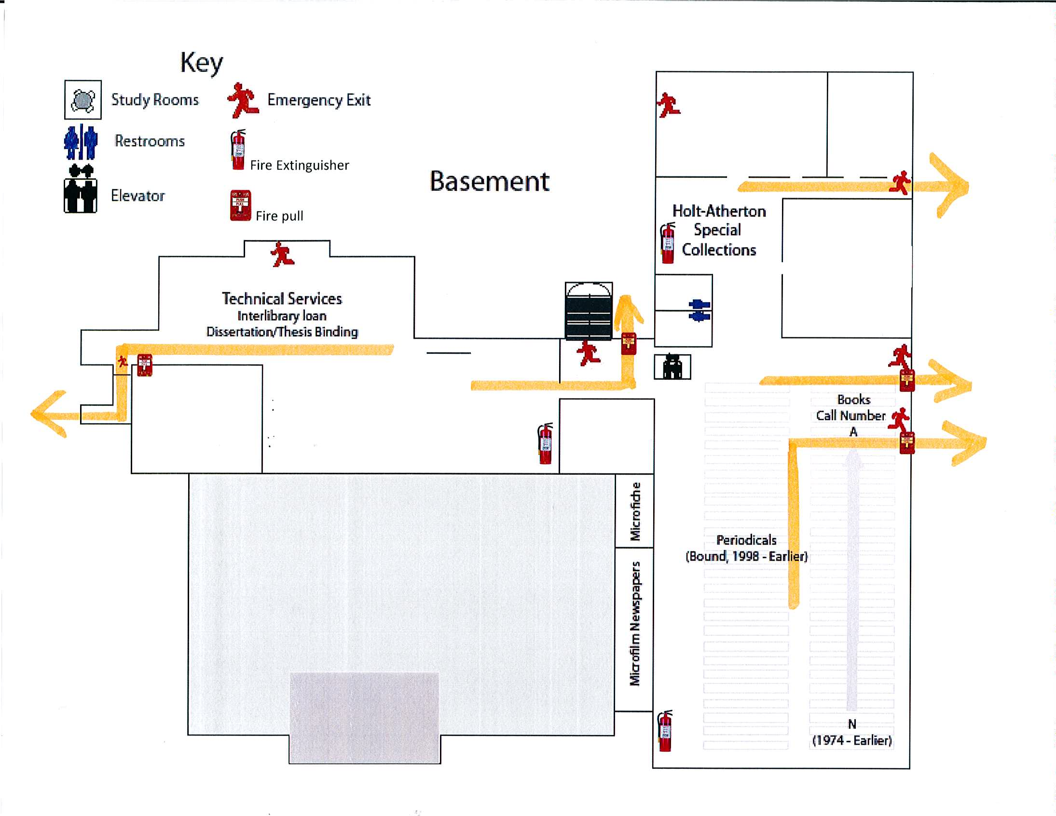

Em. Phone button
Discovery Services
William Knox Holt Library Administration

Garden Level

First Floor:

Currently under construction. Update upon completion.

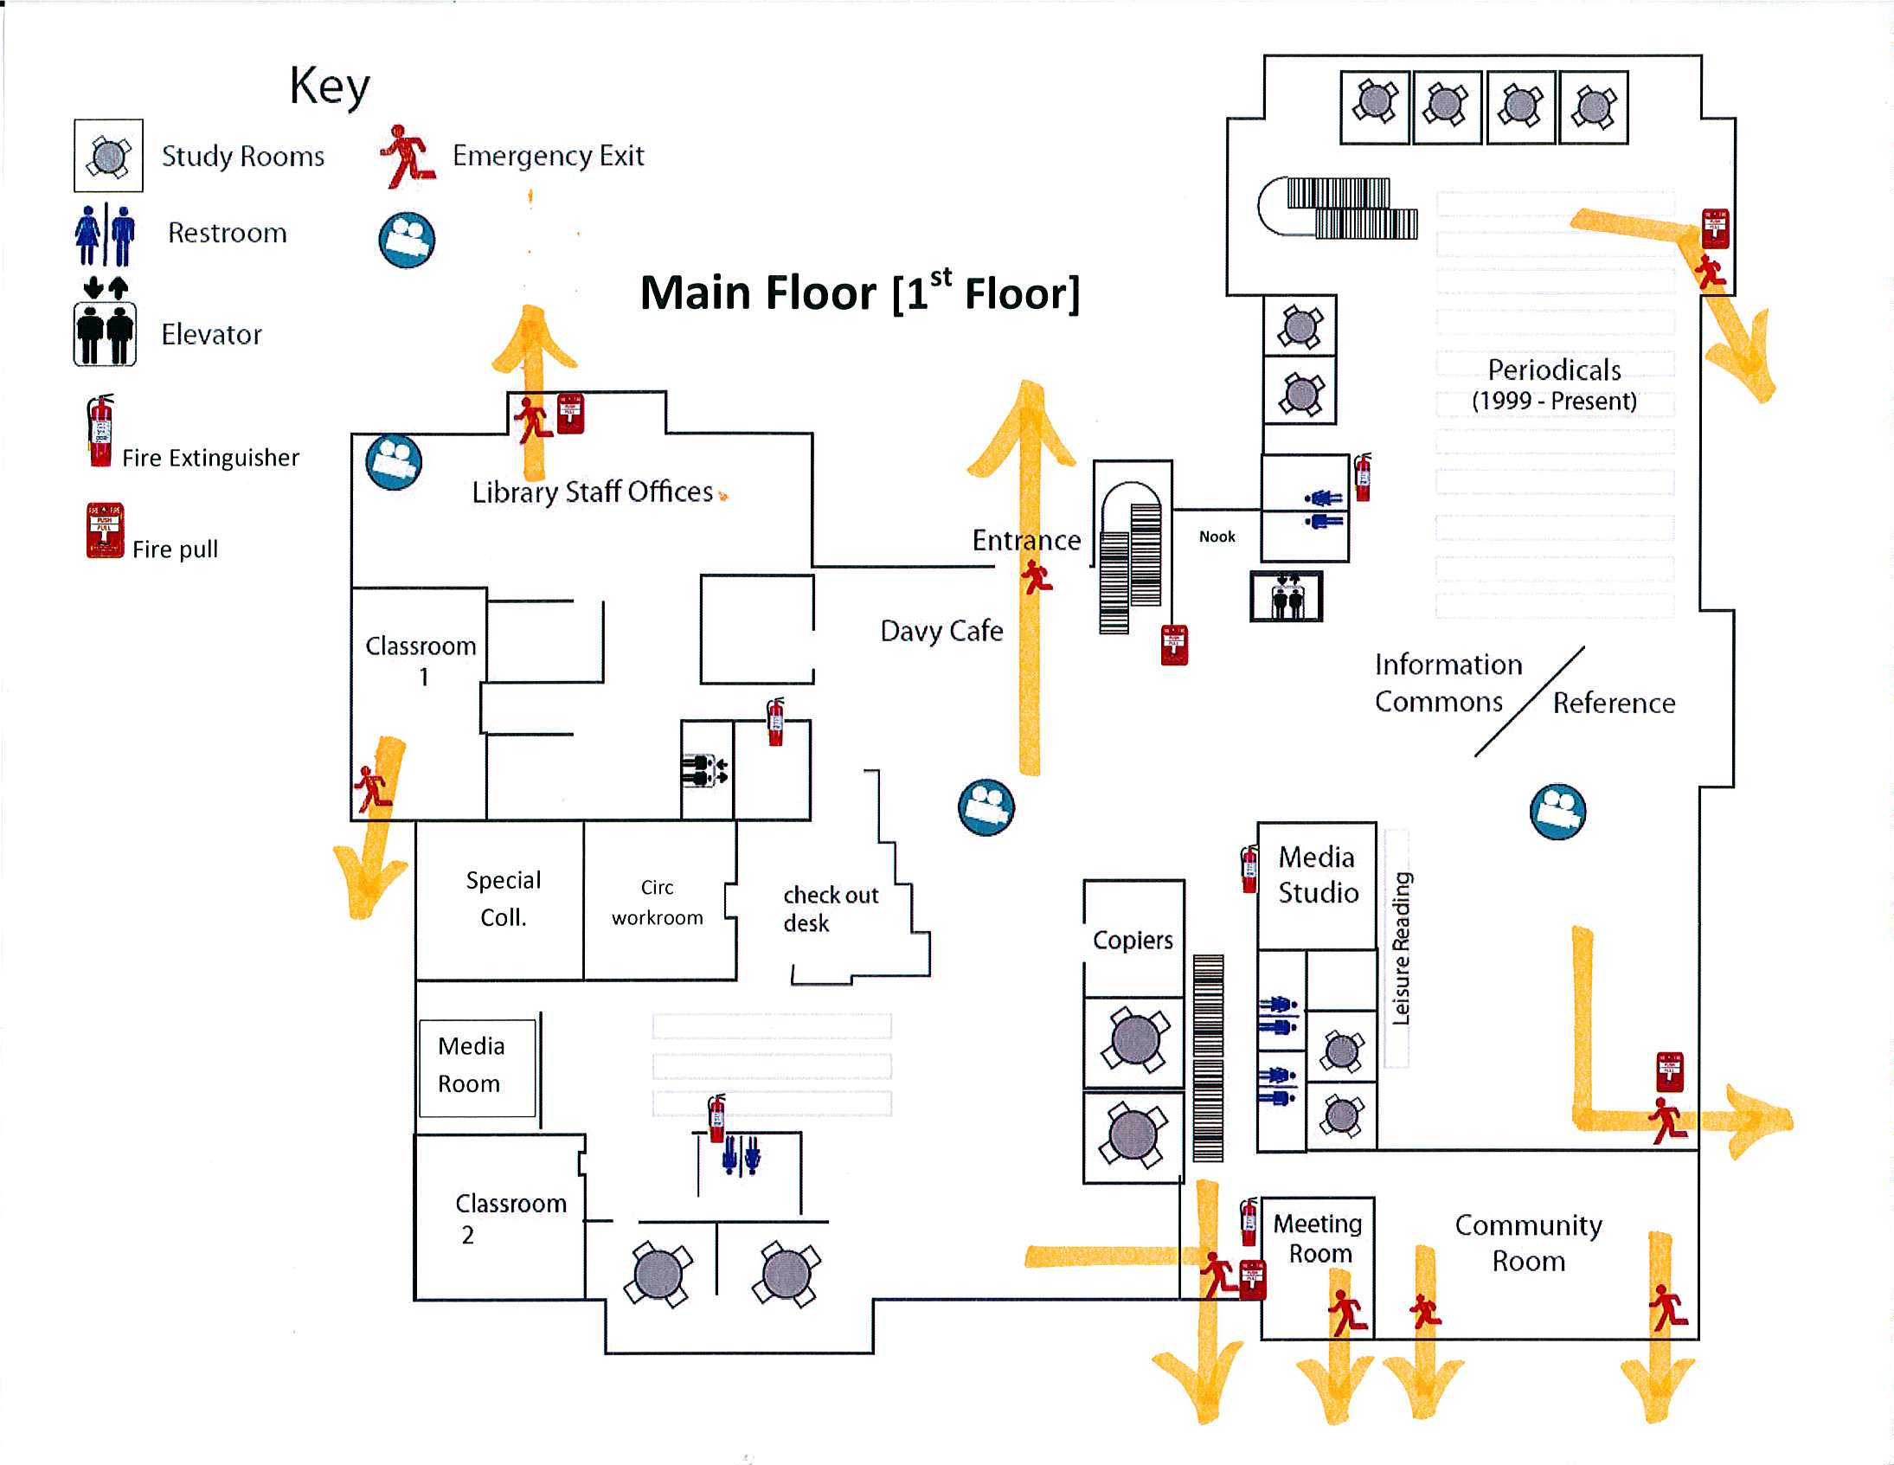

1st Floor is currently under construction and only accessible to authorized personnel. Updates after construction completion.

Second Floor:

NOTE: North emergency stairs are inaccessible due to construction.

From south-east side:
- Persons should leave through the emergency staircase on the northeast area by going through CTL.
- Persons should leave through the staircase on the south near current As Us desk and exit out the south entrance.
- Persons needing help evacuating should head for areas of refuge to wait for assistance.

From north-east side, and ONLY in extreme emergency:
- Persons should leave through the main staircase on the north to the 1st floor and out the north exit (CAUTION, this is going through a construction area).
- If deemed safe, persons should leave through the exit south entrance by going down stairs near current As Us desk.
- Persons needing help evacuating should head for areas of refuge to wait for assistance.

From south-west side:
- Persons should leave through the staircase on the south and out through the south exit.
- Persons should leave through the emergency staircase on the northeast area by going through CTL.
- Persons needing help evacuating should head for areas of refuge to wait for assistance.

From the CTL (Center for Teaching and Leaning) and (Student Writing Center):
- Persons should leave through the emergency stairwell and down to the first floor, exiting out the emergency door to designated meeting area.
- Persons should leave through the staircase on the south and out through the south exit.
- Persons needing help evacuating should head for areas of refuge to wait for assistance.

The elevator should not be used in case of emergency.

Proceed to designated safe meeting area. See map pg. 22.
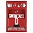
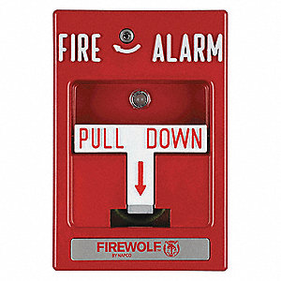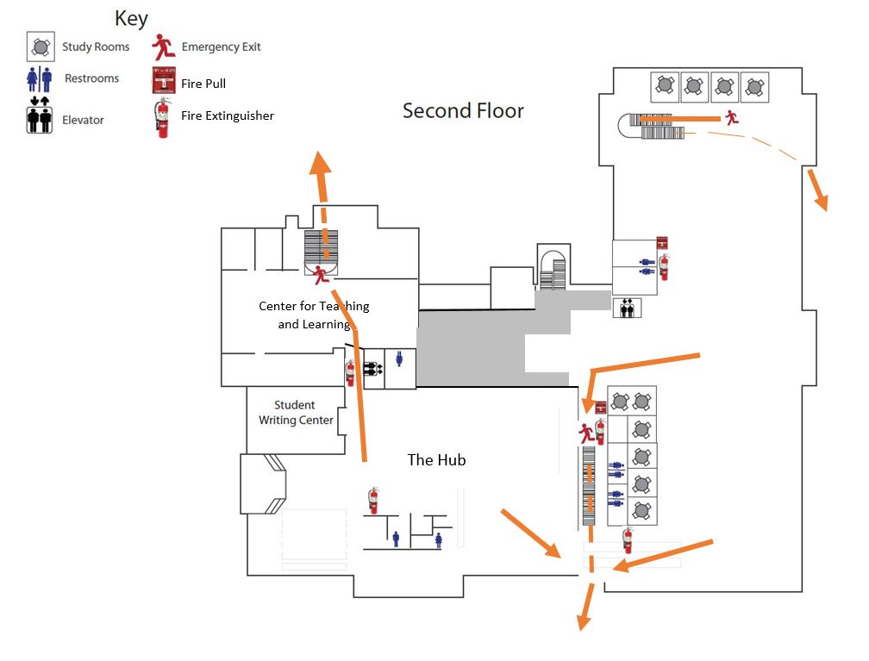
Em. Phone button

Third Floor:

From all areas on the third floor:
- Persons should take the North emergency stairwell, exiting to the first floor and out the door to designated meeting area.
- Persons needing help evacuating should head for areas of refuge to wait for assistance.

The elevator should not be used in case of emergency.
Proceed to designated safe meeting area. See map pg. 22.

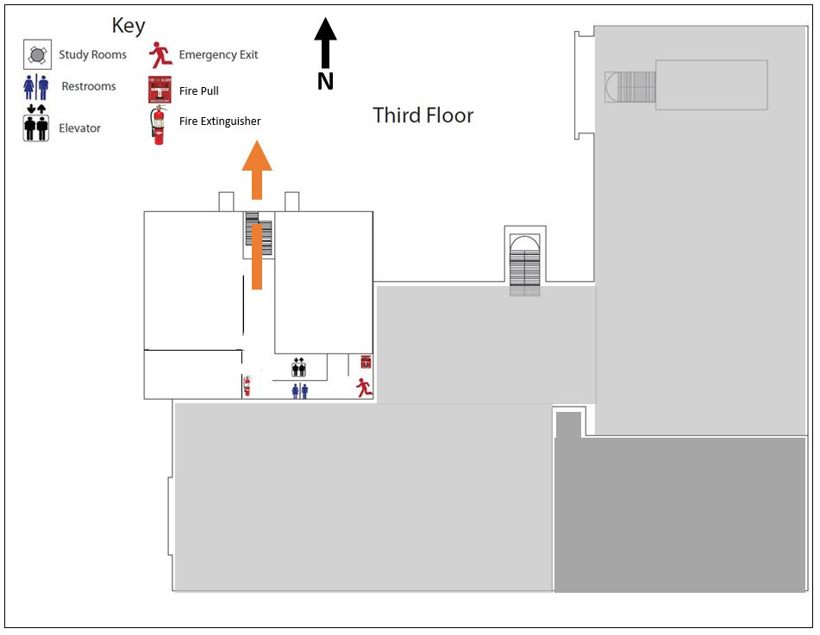
Em. Phone button

EMERGENCY LEADS

18
Garden Level: Leads: ---------- 000-000-0000 / 000-000-0000, -------------- 000-000-0000 / 000-000-0000
First Floor: [During renovations] ------------ 000-000-0000, ------------------- 000-000-0000, ------------------- 000-000-0000
Second Floor: Leads: ----------------------- 000-000-0000 / 000-000-0000, -------------------- 000-000-0000 / 000-000-0000, --------------------------- 000-000-0000 / 000-000-0000, ----------------- 000-000-0000 / 000-000-0000, ---------------- 000-000-0000 / 000-000-0000
Third Floor: Leads: -------------------- 000-000-0000 / 000-000-0000, ------------------ 000-000-0000 / 000-000-0000

RESPONSIBILITES:
Leads

Leads are identified and appointed for each floor and department. Duties include but are not limited to the following:

- Develop and implement the evacuation plan for the University William Knox Holt Library.
- Be familiar with the evacuation plan and its procedures.
- Assist the building occupants with the directions of evacuation routes, communicate the need to evacuate, ensure occupants are/have evacuated the building, and close (but do not lock) door(s) on the way out.
- Work with other team leaders to help a disabled person exit the building, by moving to an area of refuge or move to a safe place to stay.
- Take a head count and report evacuation status to other team leaders after exiting the building.
- Work with Pacific’s Public Safety department, other emergency response personnel, and/or each department within the building affected by the evacuation plan.
- When notified to do so by emergency response personnel or campus Public Safety, inform building occupants when it is safe to re-enter the building.

NOTE: In the absence of a floor Lead, another staff member must take the lead.

Employees, students and visitors are responsible for evacuating the building immediately when notified to do so and to cooperate fully with the University William Knox Holt Library Leads in all aspects of these guidelines as well as emergency personnel.

EVACUATION INSTRUCTIONS: Do’s and Do-not’s

A. PREPARING FOR AN EVACUATION

- Know your building’s floor plan. Know where the stairs and fire extinguishers are located.
- Determine in advance the nearest exit from your work location and the route you will follow to reach that exit in an emergency.
- Know the locations of alternate exits from your area.
- If you work in an office, know exactly how many doors you will pass along your evacuation route before you reach the nearest exit door. In heavy smoke, exit signs may be invisible. Even in heavy smoke, you can count the number of doors as you pass, so you will know when you reach the exit door.
- Participate in all evacuation drills and take them seriously.

B. DURING AN EVACUATION

- If time and conditions permit, secure your workplace and take with you important personal items such as car keys, purse, medication, glasses.
- Follow instructions from emergency personnel.
- Check doors for heat before opening. (Do not open door if hot).
- WALK—do not run. Do not push or crowd.
- Keep noise to a minimum so you can hear emergency instructions.
- Use handrails in stairwells; stay to the right.
- Assist people with disabilities if at all possible.
- Know your assembly point(s) and move to your closest assembly point unless otherwise it is obstructed or you are instructed otherwise.

If relocating outside the building:

- Move quickly away from the building.
- Watch for falling glass and other debris.
- Stay with your Leads.
- Keep roadways and walkways clear for emergency vehicles.
- If you have relocated away from the building, DO NOT RETURN until notified it is safe to do so.
- Whenever the fire alarms/strobes are activated, occupants MUST evacuate the building and reassemble at your designated assembly point. Occupants on floors above the ground floor must use emergency exit stairwells to leave the building. DO NOT USE ELEVATORS!!!!

- For certain emergencies such as a bomb threat or a natural gas leak, the fire alarms/strobes may not be activated. Instead, building Leads will move through the building and order the occupants to evacuate.

- Emergency evacuation signage is posted in buildings so that occupants can become familiar with the evacuation routes and assembly points for their area.

C. EVACUATION OF DISABLED PERSONS

- In all cases, help people in need only if it is safe to do so. If you determine it is not safe, tell the person to stay where they are and evacuate.
- Once you evacuate, let the officer’s in charge know where the person is waiting for help.

Visually Impaired Persons:

Most visually impaired persons will be familiar with their immediate area. In an emergency situation, describe the nature of the emergency and offer to act as a “sighted guide;” offer your elbow and escort him/her to a safe place. As you walk, describe where you are and advise of any obstacles. When you have reached safety, orient the person as to where you are and ask if any further assistance is needed.

Hearing Impaired Persons

Because persons with impaired hearing may not perceive emergency alarms, an alternative warning technique is required. Two methods or warning:

1. Write a note describing the emergency and nearest evacuation route. Such as, “Fire. Go out rear door to the right and down, NOW!”
2. Turn the light switch off and on to gain attention and then indicate through gestures what is happening and what to do.

AREA OF REFUGE / EMERGENCY PHONE BUTTONS

For the purpose inside the William Knox Holt Library, Areas of Refuge have been designated and Emergency Phone Button units have been placed.

Areas of refuge, are areas inside a building where people can wait in times of emergency and when evacuation is not possible. If emergency button is pushed, person should wait near the button for a rescue team to come to assist. Phones are connected directly to Public Safety and alerts them to where in the building the person is.

** NOTE: IS CURRENTLY BEING INSTALLED DURING RENOVATIONS. MAPS INDICATE WHERE THEY ARE OR WILL BE LOCATED.

Preferred meeting area
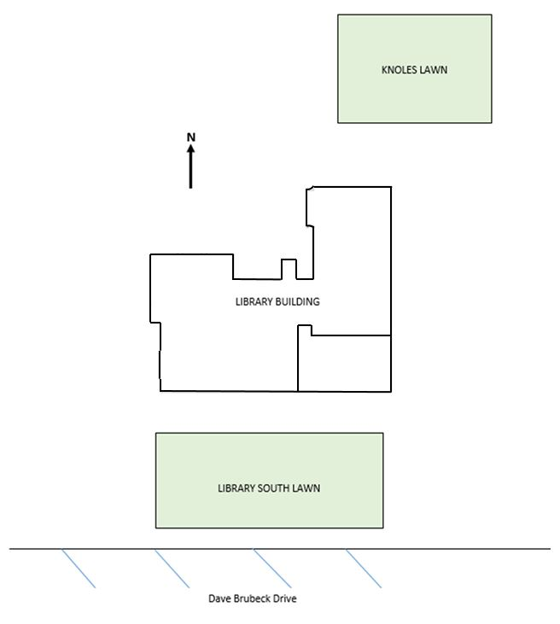
DESIGNATED SAFE OUTSIDE MEETING AREAS

Depending on the situation, the South lawn will only be used as a meeting area if Knoles Lawn is inaccessible or compromised.

William Knox Holt Library Building

Secondary meeting area

WILLIAM KNOX HOLT LIBRARY BUILDING OCCUPANTS

23

GARDEN  First last name wk: 000-000-0000  cell: 000-000-0000  First last name wk: 000-000-0000  cell: 000-000-0000  First last name wk: 000-000-0000  cell: 000-000-0000  First last name wk: 000-000-0000  cell: 000-000-0000  First last name wk: 000-000-0000  cell: 000-000-0000  First last name wk: 000-000-0000  cell: 000-000-0000  First last name wk: 000-000-0000  cell: 000-000-0000  First last name wk: 000-000-0000  cell: 000-000-0000  First last name wk: 000-000-0000  cell: 000-000-0000 | First last name wk: 000-000-0000  cell: 000-000-0000  First last name wk: 000-000-0000  cell: 000-000-0000  First last name wk: 000-000-0000  cell: 000-000-0000  First last name wk: 000-000-0000  cell: 000-000-0000  First Floor  (During Construction)  First last name wk: 000-000-0000  cell: 000-000-0000  First last name wk: 000-000-0000  cell: 000-000-0000  Second Floor  First last name wk: 000-000-0000  cell: 000-000-0000  First last name wk: 000-000-0000  cell: 000-000-0000 | First last name wk: 000-000-0000  cell: 000-000-0000  First last name wk: 000-000-0000  cell: 000-000-0000  First last name wk: 000-000-0000  cell: 000-000-0000  First last name wk: 000-000-0000  cell: 000-000-0000  First last name wk: 000-000-0000  cell: 000-000-0000  First last name wk: 000-000-0000  cell: 000-000-0000  First last name wk: 000-000-0000  cell: 000-000-0000  First last name wk: 000-000-0000  cell: 000-000-0000  First last name wk: 000-000-0000  cell: 000-000-0000 | First last name wk: 000-000-0000  cell: 000-000-0000  First last name wk: 000-000-0000  cell: 000-000-0000  Third Floor  First last name wk: 000-000-0000  cell: 000-000-0000  First last name wk: 000-000-0000  cell: 000-000-0000  First last name wk: 000-000-0000  cell: 000-000-0000  First last name wk: 000-000-0000  cell: 000-000-0000  First last name wk: 000-000-0000  cell: 000-000-0000  First last name wk: 000-000-0000  cell: 000-000-0000 | Mezzanine  First last name wk: 000-000-0000  cell: 000-000-0000  First last name wk: 000-000-0000  cell: 000-000-0000  First last name wk: 000-000-0000  cell: 000-000-0000  Rite Aid Information Commons  First last name wk: 000-000-0000  cell: 000-000-0000

William Knox Holt Library Building Reporting Protocols

Fire/Life/Safety

Always contact Public Safety to report fire/life/safety issues.
Dispatch - 000-000-0000

Also, contact University Libraries’ Business Manager ------------------- - -------------@pacific.edu, 000-000-0000 (work), 000-000-0000 (cell/text) - between 8 – 5, Monday – Friday, who will contact Ask Us Desk.

Or contact Ask Us desk - 000-000-0000- if outside regular business hours, at night, or on weekends.

Renovation

Contact University Libraries’ Business Manager ------------------- - -------------@pacific.edu, 000-000-0000 (work), 000-000-0000 (cell/text) - from 8 – 5, Monday – Friday. John will notify -------------– 000-000-0000 (cell/text), -------------- - 000-000-0000 (cell/text),

Before or after those hours (8-5, M-F) and on weekends, report building issues to Ask Us Desk - 000-000-0000, who will either contact ---------- 000-000-0000 – or Public Safety - 000-000-0000 (phone).

Note: typically, renovation related issues will occur when contractor on site.

In the case of elevator malfunction, also contact ------------- - 000-000-0000, who will reschedule developmental math and writing classes to alternative accessible locations.

Facilities

From 8 – 5, Monday through Friday, contact University Libraries’ Business/Facility Manager ------------------ – ----------@pacific.edu, 000-000-0000 (work), 000-000-0000 (cell/text) - or Acquisitions Specialist ------------- – 000-000-0000, or Physical Plant – 000-000-0000. Outside of regular business hours, contact Ask Us Desk- 000-000-0000.

January 28, 2019

Appendix
STOP THE BLEED

Call 9-1-1 or 000-000-0000 (campus phone)

Ensure Your Safety
- Before you offer any help, you must ensure your own safety!
- If you become injured, you will not be able to help the victim.
- Provide care to the injured person if the scene is safe for you to do so.
- If, at any time, your safety is threatened, attempt to remove yourself (and the victim if possible) from danger and find a safe location.
- Protect yourself from blood-borne infections by wearing gloves, if available.

Look for Life-Threatening Bleeding
- Find the source of bleeding
- Open or remove the clothing over the wound so you can clearly see it. By removing clothing, you will be able to see injuries that may have been hidden or covered.
- Look for and identify “life-threatening” bleeding. Examples include:
  - Blood that is spurting out of the wound.
  - Blood that won’t stop coming out of the wound.
  - Blood that is pooling on the ground.
  - Clothing that is soaked with blood.
  - Bandages that are soaked with blood.
  - Loss of all or part of an arm or leg.
  - Bleeding in a victim who is now confused or unconscious.

Compress and Control

Key Point
There are a number of methods that can be used to stop bleeding and they all have one thing in common—compressing a bleeding blood vessel in order to stop the bleeding.

If you don’t have a trauma first aid kit:
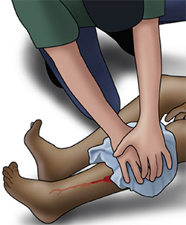
Apply direct pressure on the wound (Cover the wound with a clean cloth and apply pressure by pushing directly on it with both hands)
- Take any clean cloth (for example, a shirt) and cover the wound.
- If the wound is large and deep, try to “stuff” the cloth down into the wound.
- Apply continuous pressure with both hands directly on top of the bleeding wound.
- Push down as hard as you can.
- Hold pressure to stop bleeding. Continue pressure until relieved by medical responders.

If you do have a trauma first aid kit:
For life-threatening bleeding from an arm or leg and a tourniquet is NOT available OR for bleeding from the neck, shoulder or groin:
- Pack (stuff) the wound with a bleeding control (also called a hemostatic) gauze, plain gauze, or a clean cloth and then apply pressure with both hands
- Open the clothing over the bleeding wound. (A)
- Wipe away any pooled blood.
- Pack (stuff) the wound with bleeding control gauze (preferred), plain gauze, or clean cloth. (B)
- Apply steady pressure with both hands directly on top of the bleeding wound. (C)
- Push down as hard as you can.
- Hold pressure to stop bleeding. Continue pressure until relieved by medical responders.
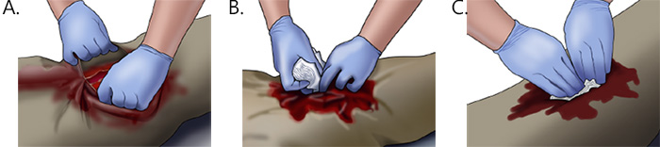

For life-threatening bleeding from an arm or leg and a tourniquet is available:
- Apply the tourniquet
- Wrap the tourniquet around the bleeding arm or leg about 2 to 3 inches above the bleeding site (be sure NOT to place the tourniquet onto a joint—go above the joint if necessary).
- Pull the free end of the tourniquet to make it as tight as possible and secure the free end. (A)
- Twist or wind the windlass until bleeding stops. (B)
- Secure the windlass to keep the tourniquet tight. (C)
- Note the time the tourniquet was applied. (D)
Note: A tourniquet will cause pain but it is necessary to stop life-threatening bleeding.
